标题：Pigeonhole Design: Balancing Sequential Experiments from an Online Matching Perspective
作者及机构:
Jinglong Zhao: Questrom School of Business, Boston University, Boston, Massachusetts 02215
Zijie Zhou: Operations Research Center, Massachusetts Institute of Technology, Cambridge, Massachusetts 02139
摘要: Practitioners and academics have long appreciated the benefits of covariate balancing when they conduct randomized experiments. For web-facing firms running online A/B tests, however, it still remains challenging in balancing covariate information when experimental subjects arrive sequentially. In this paper, we study an online experimental design problem, which we refer to as theonline blocking problem. In this problem, experimental subjects with heterogeneous covariate information arrive sequentially and must be immediately assigned into either the control or the treated group. The objective is to minimize the total discrepancy, which is defined as the minimum weight perfect matching between the two groups. To solve this problem, we propose a randomized design of experiment, which we refer to as the pigeonhole design. The pigeonhole design first partitions the covariate space into smaller spaces, which we refer to as pigeonholes, and then, when the experimental subjects arrive at each pigeonhole, balances the number of control and treated subjects for each pigeonhole. We analyze the theoretical performance of the pigeonhole design and show its effectiveness by comparing against two well-known benchmark designs: the matched-pair design and the completely randomized design. We identify scenarios when the pigeonhole design demonstrates more benefits over the benchmark design. To conclude, we conduct extensive simulations using Yahoo! data to show a 10.2% reduction in variance if we use the pigeonhole design to estimate the average treatment effect.
AI标题: 鸽巢设计革新在线A/B测试：协变量动态平衡方差降10.2%
AI精炼: **论文总结** 该研究聚焦在线实验设计领域，旨在解决动态场景下协变量平衡的难题：当受试者**按顺序到达**且需实时分配至对照组或处理组时，如何最小化两组间的协变量差异。传统方法面临两难——**完全随机设计**忽略协变量信息导致匹配误差大，而**匹配配对设计**依赖未来数据无法在线应用。 作者提出**鸽巢设计（Pigeonhole Design）**，其核心是通过动态分块与局部平衡实现高效匹配： 1. **分块策略**：将协变量空间划分为均匀“鸽巢”子区域； 2. **实时分配**：在每块内动态调整，优先平衡当前子区域的对照组与处理组数量； 3. **容错机制**：对未匹配样本进行跨块优化，避免累积误差。 理论证明显示，该方法在单维连续协变量下将差异从完全随机的\(O(T^{1/2})\)降至\(O(T^{1/4})\)，接近离线最优的匹配配对设计。基于雅虎数据的仿真实验进一步验证，其估计方差较完全随机设计降低10.2%。这一方法为在线平台提供了一种兼顾实时性与准确性的实验设计方案。
关键词:
鸽巢设计
在线阻塞问题
最小权重完美匹配
协变量动态平衡
完全随机设计
匹配配对设计
差异最小化
在线向量平衡
学术要点: 学术要点 1：在线阻塞问题（Online Blocking Problem） 在顺序到达的实验中，需即时分配受试者至控制组与处理组，并在对抗性协变量分布下最小化组间差异的优化问题。|||
学术要点 2：鸽子洞设计（Pigeonhole Design） 通过将协变量空间划分为均匀子空间（pigeonholes），并在每个子空间内动态平衡控制组与处理组数量的在线随机化实验设计方法。|||
学术要点 3：最小权重完美匹配（Minimum Weight Perfect Matching） 基于L2距离的两组间最优匹配策略，其总权重反映组间协变量分布差异，直接影响平均处理效应估计的偏误。|||
学术要点 4：对抗性到达模型（Adversarial Arrival Model） 假设受试者协变量由敌对方按最坏情况顺序生成的理论框架，区别于传统随机或独立同分布假设。|||
学术要点 5：协变量空间分区（Covariate Space Partitioning） 针对连续型协变量采用均匀网格划分，离散型协变量采用自然分箱的策略，平衡分区粒度与剩余未匹配样本量的权衡。
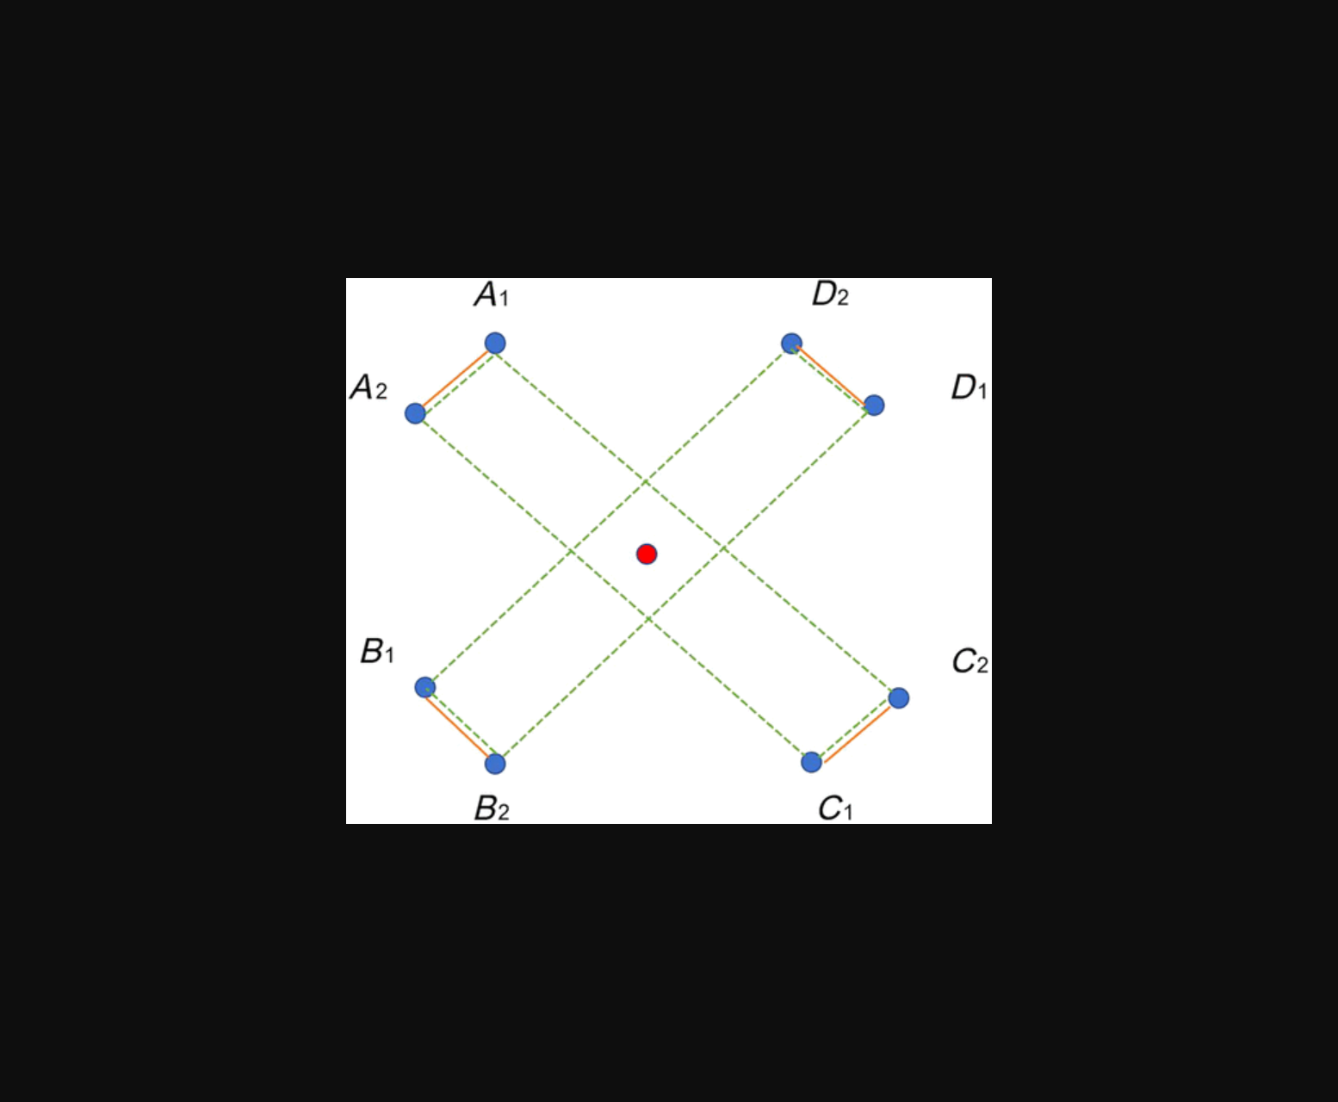
图示鸽巢设计通过协变量分区平衡实验组与对照组的分配过程。
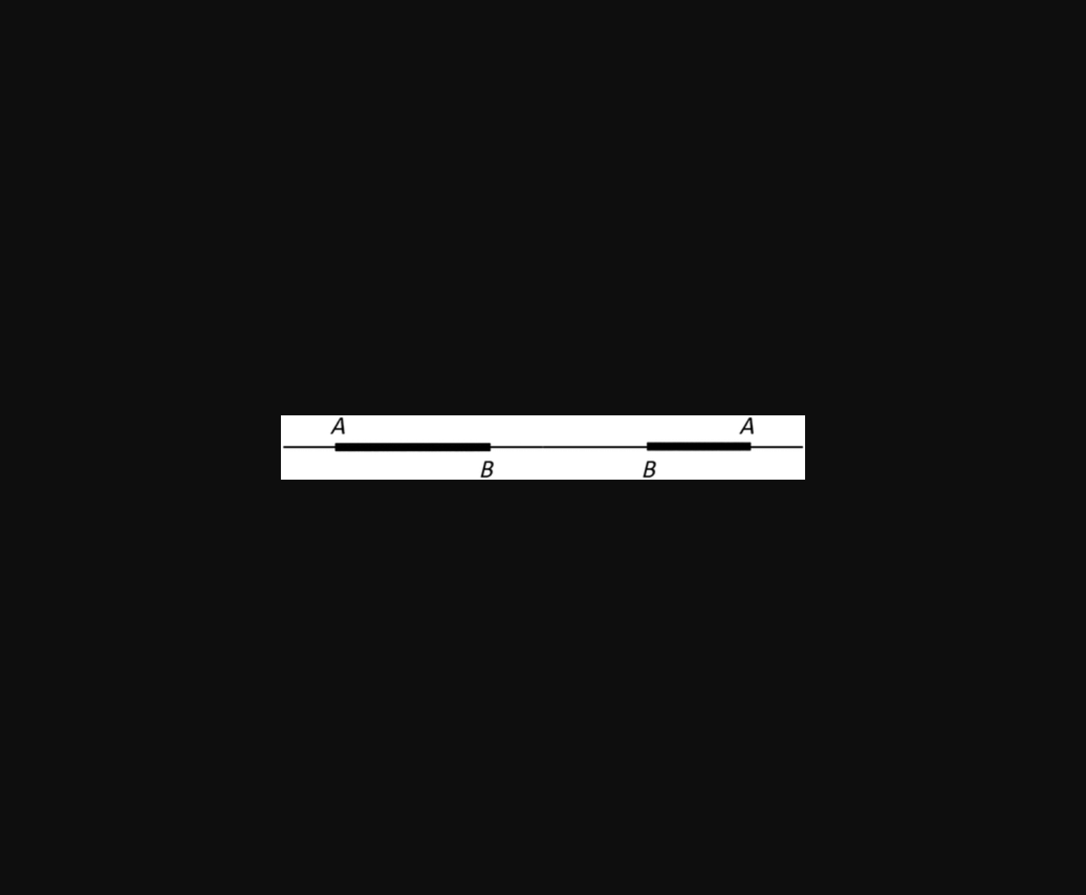
图片展示了在线鸽巢设计通过协变量分区平衡实验组与对照组的样本分布。
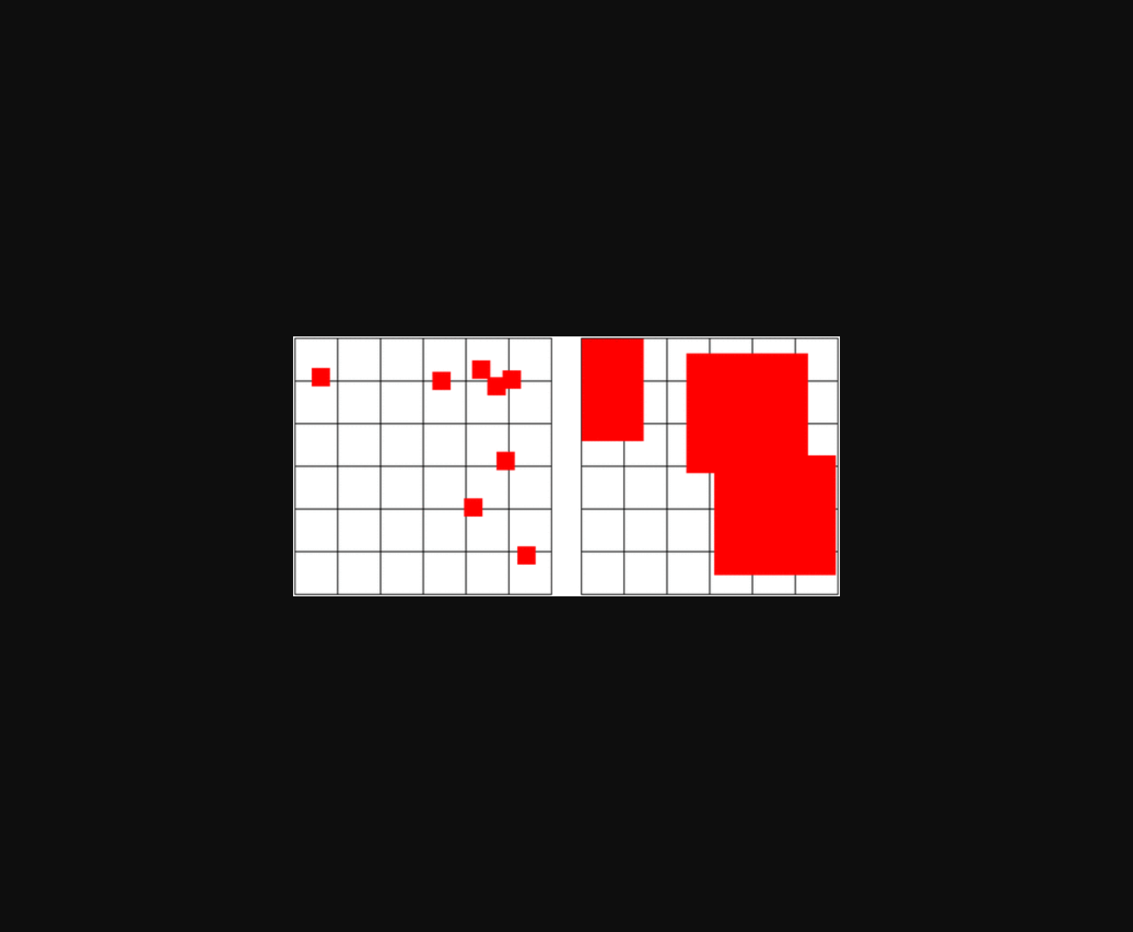
示意图展示在线实验中协变量空间的分区及组间平衡策略。
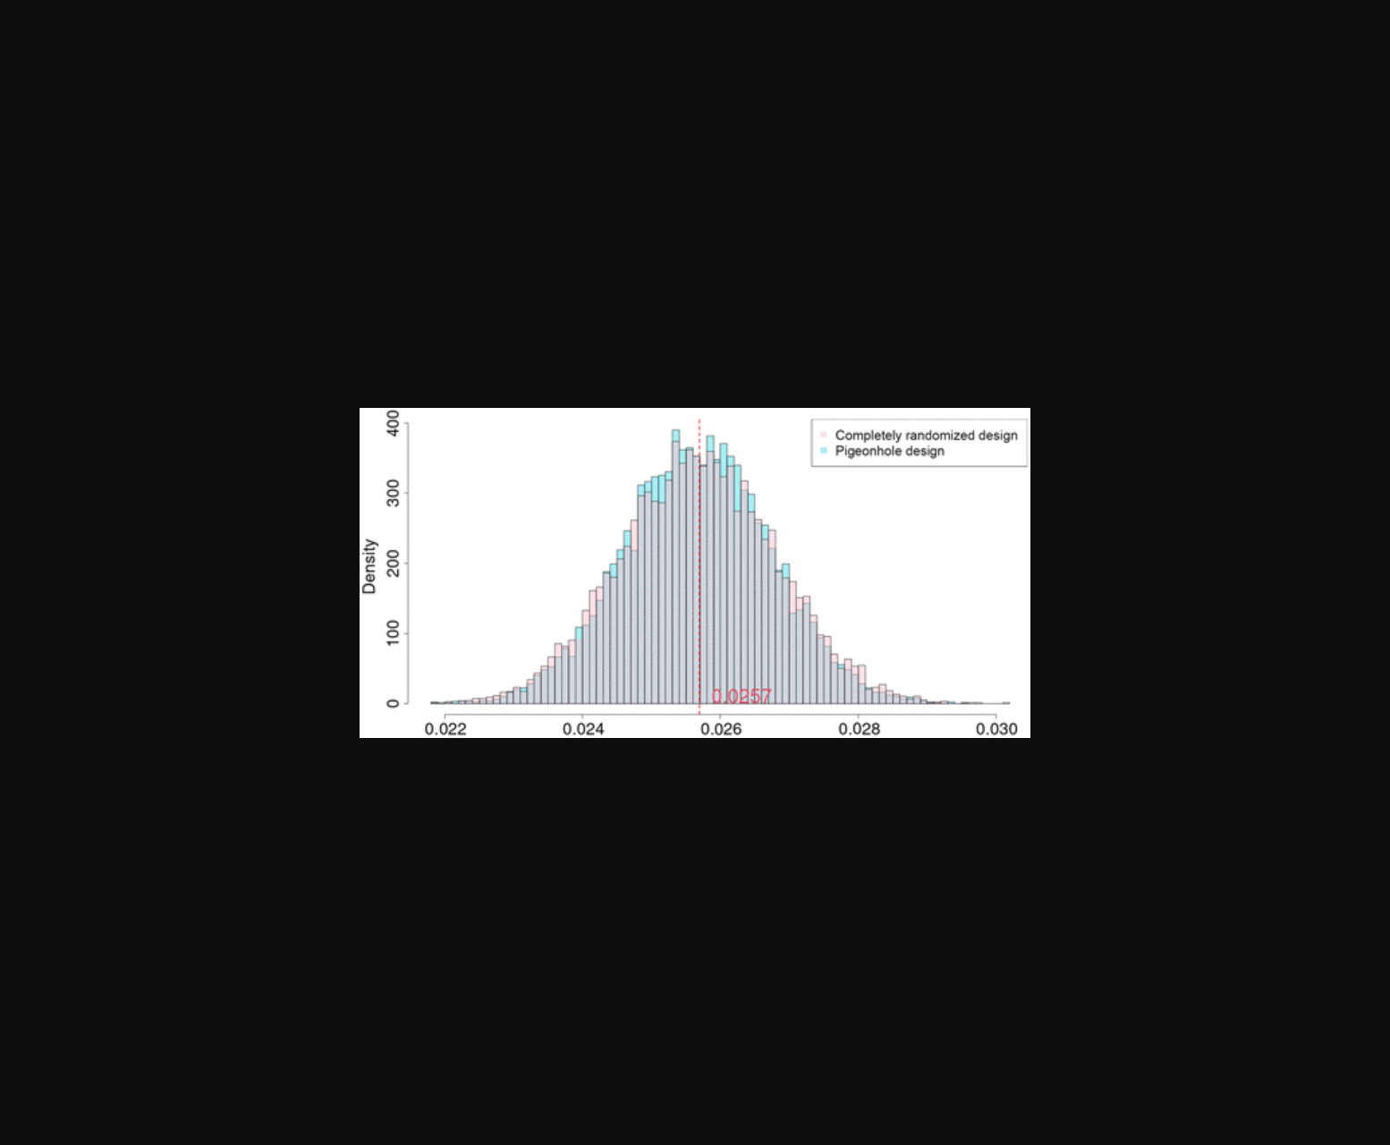
图示在线鸽巢设计通过分区平衡协变量，对比传统实验方案效果。
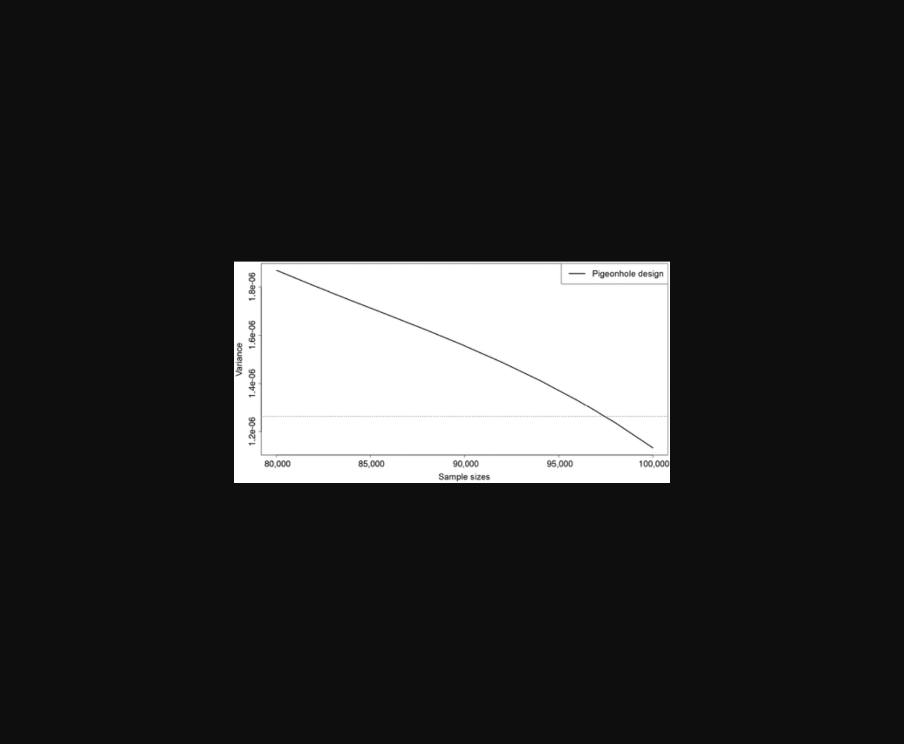
图片展示了鸽巢设计与其他实验方法在协变量平衡效果上的对比示意图。
原文链接: https://doi.org/10.1287/mnsc.2023.02184

